**POLITICAL JUGGERNAUTS:**

1. **INTRODUCTION**

**Overview**

* **Welcome to the presentation on ‘Unleashing the Powerhouses: A Quantitative Analysis of Candidates in the 2019 Lok Sabha Elections’. In this Study, we explore the quantitative who contested in the Lok Sabha elections held in the 2019. Join us as device into the data and uncover interesting insights.**

**Purpose**

* **To conduct this analysis, we collected data on candidate Profiles, election results, and voter demographics. We used statistical techniques to analyse the data and draw meaningful conclusions. Our research provides a comprehensive understanding of the candidates and their performance in the 2019 Lok Sabha elections.**

**2. PROBLEM DEFINITION & DESIGN**

**THINKING**

**(2.1) EMPATHY MAP**

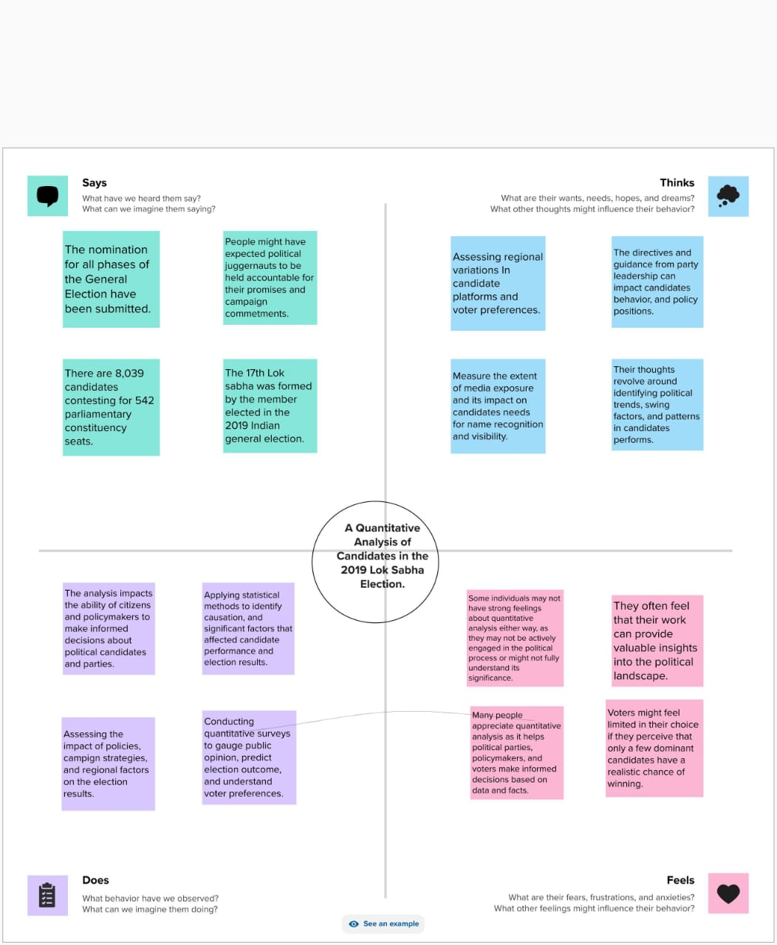

**(2.2) BRAINSTORMING MAP**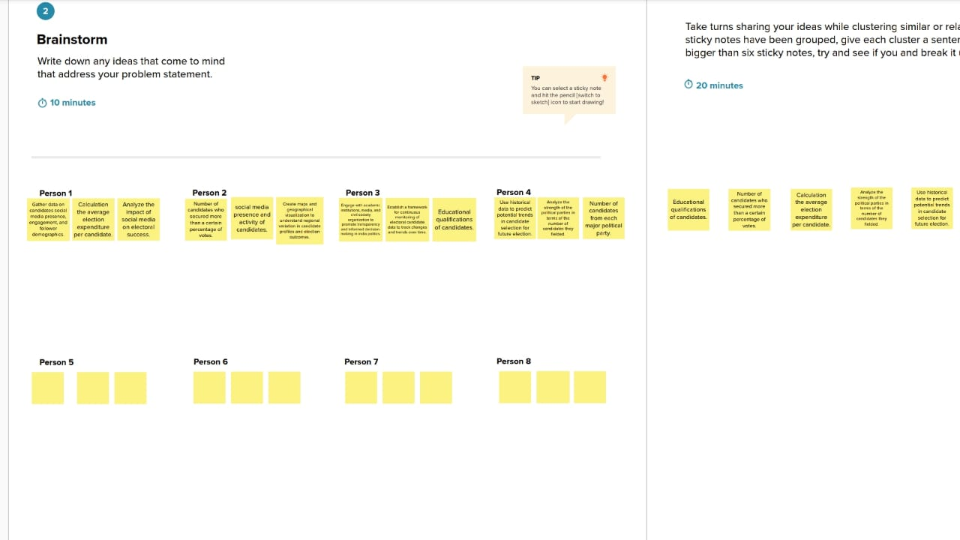

**3. DESIGN DASHBOARD**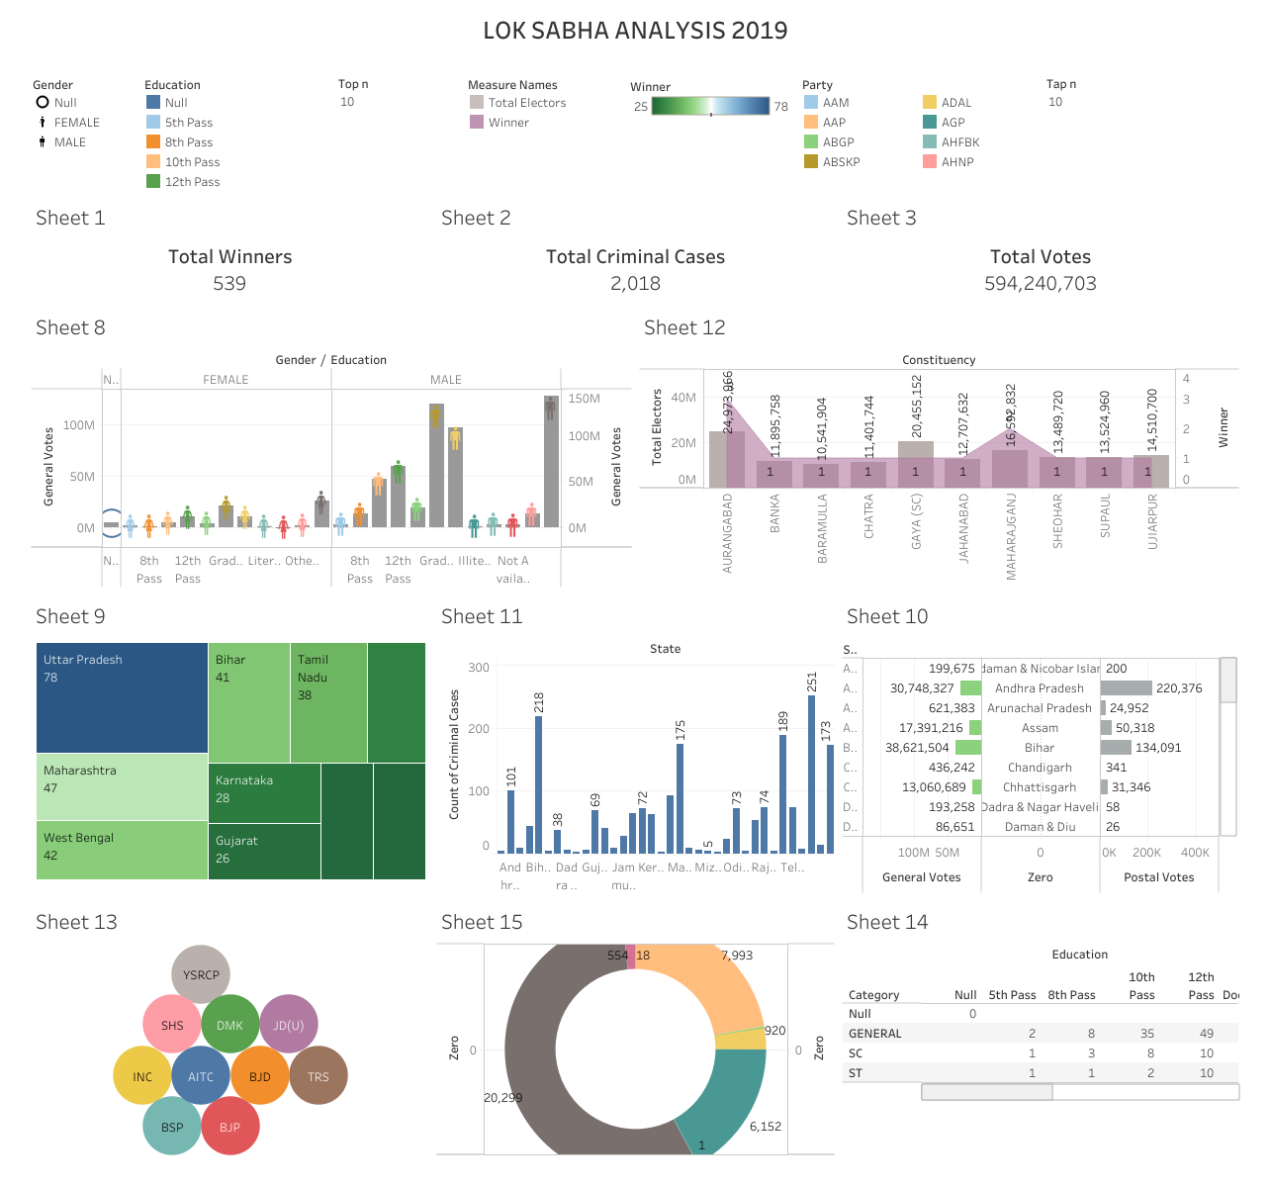

**4.STORY 1**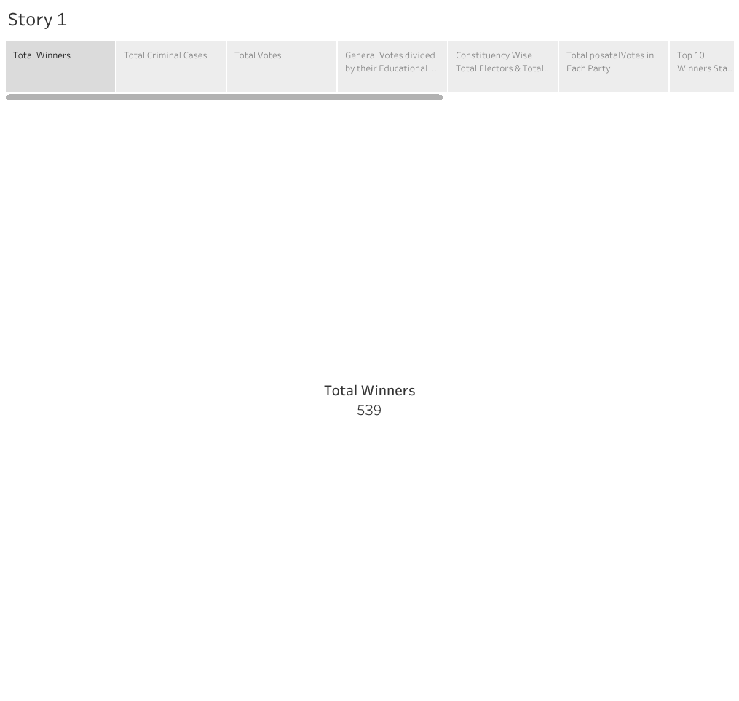

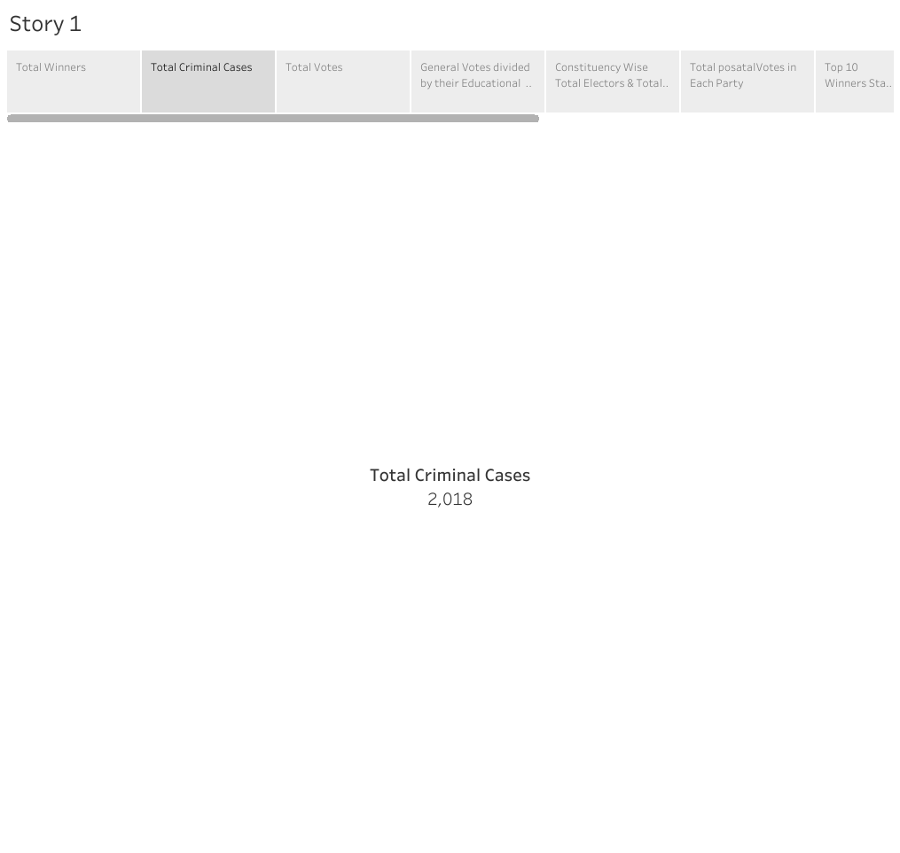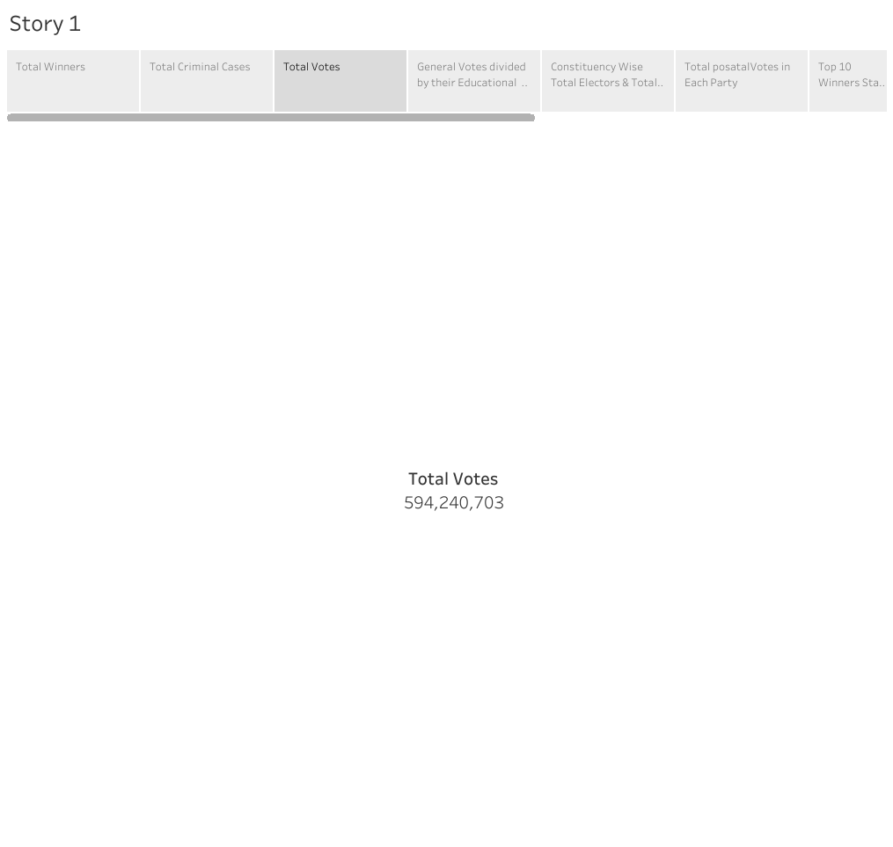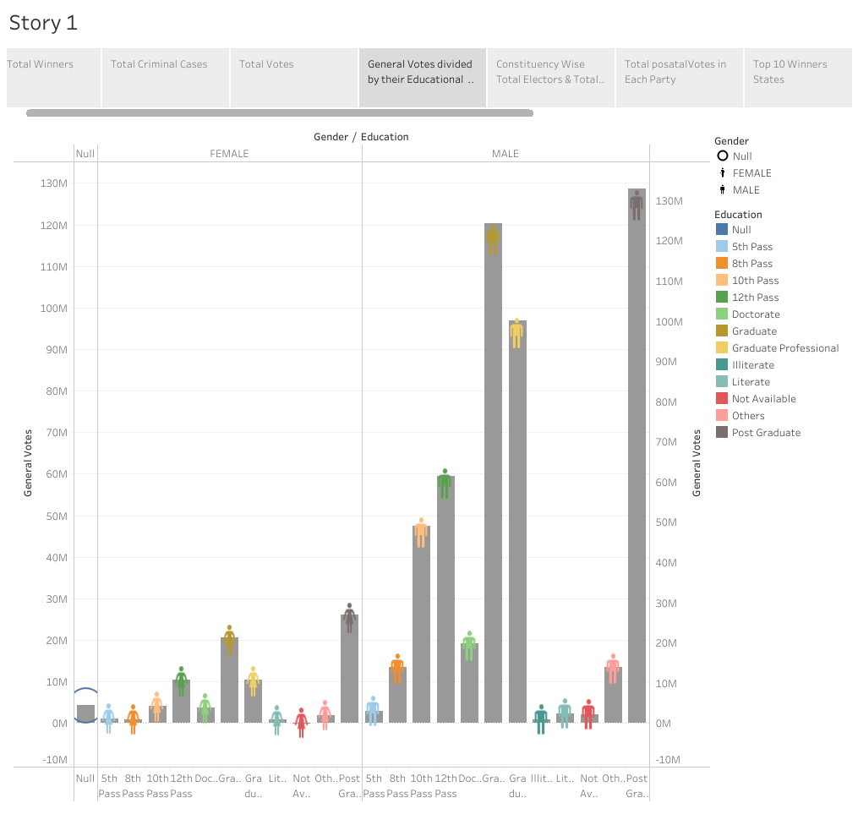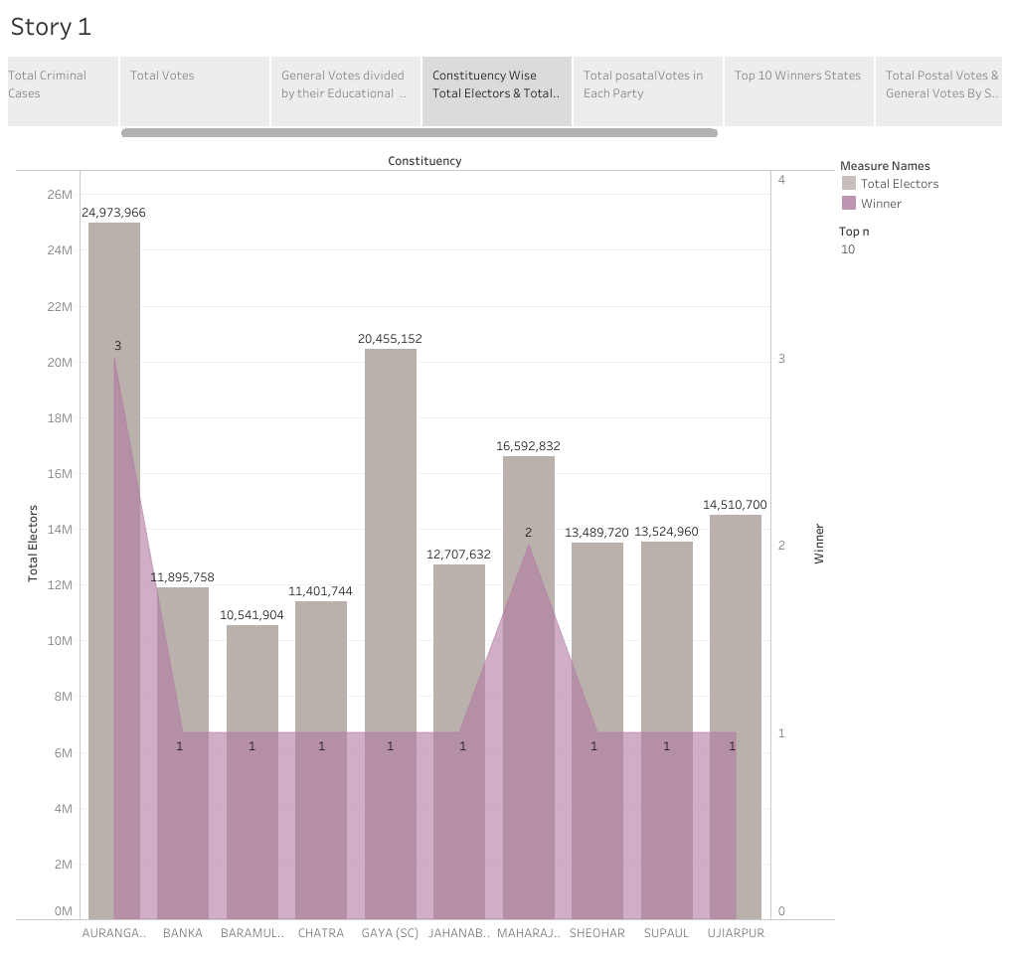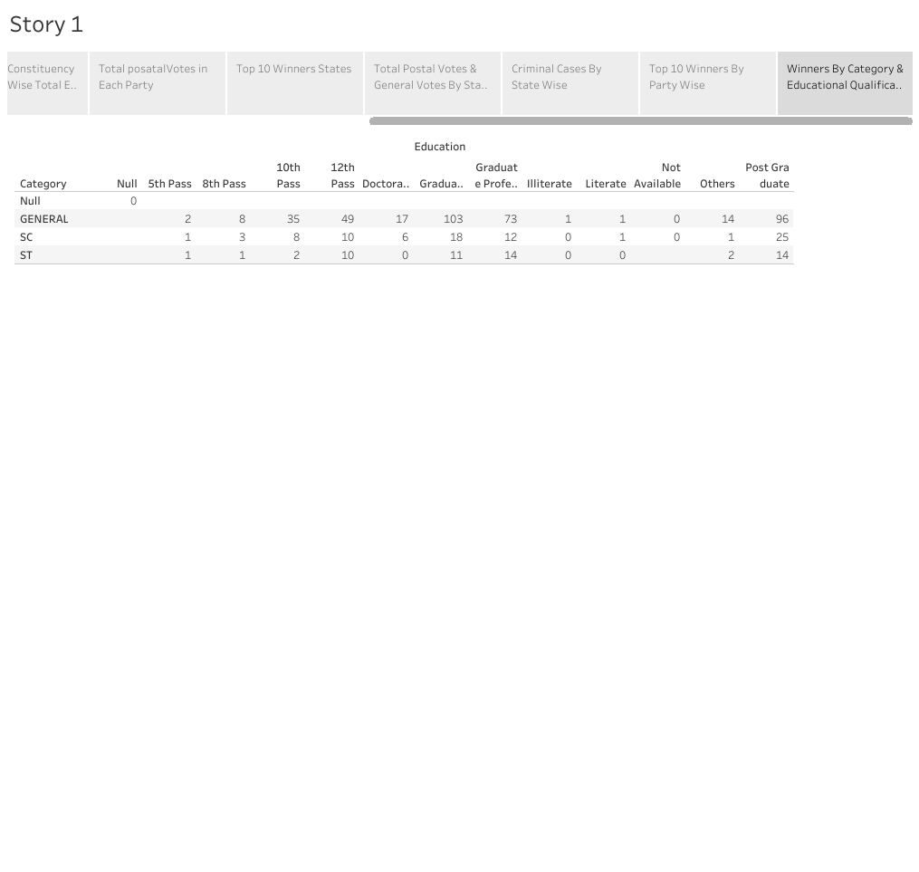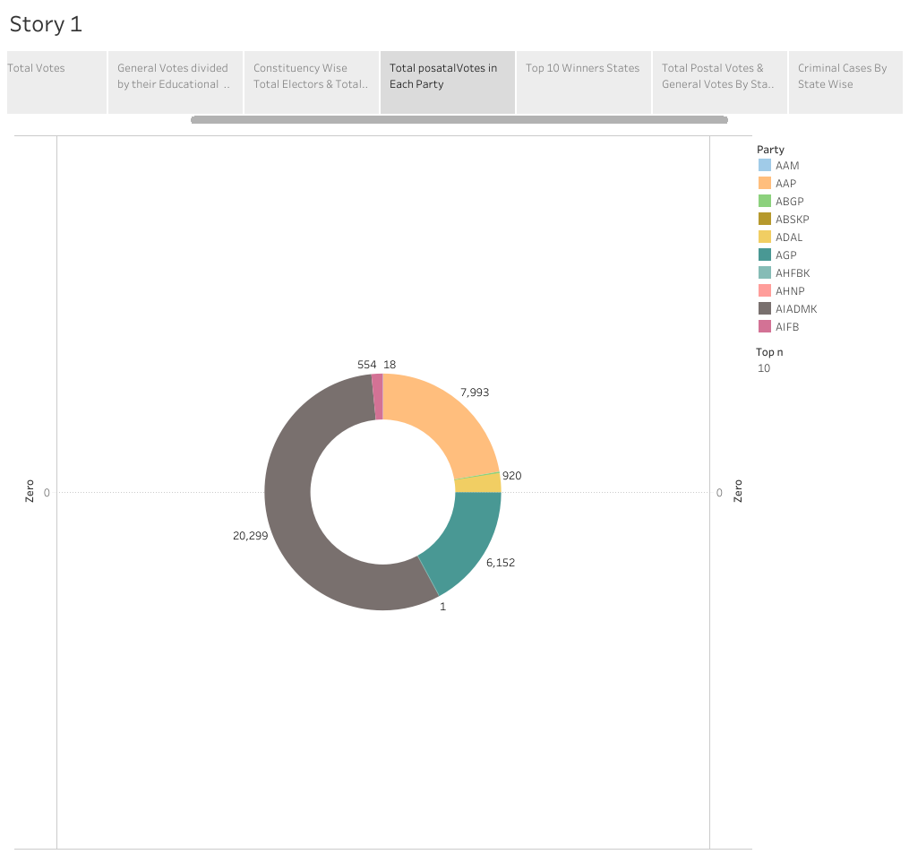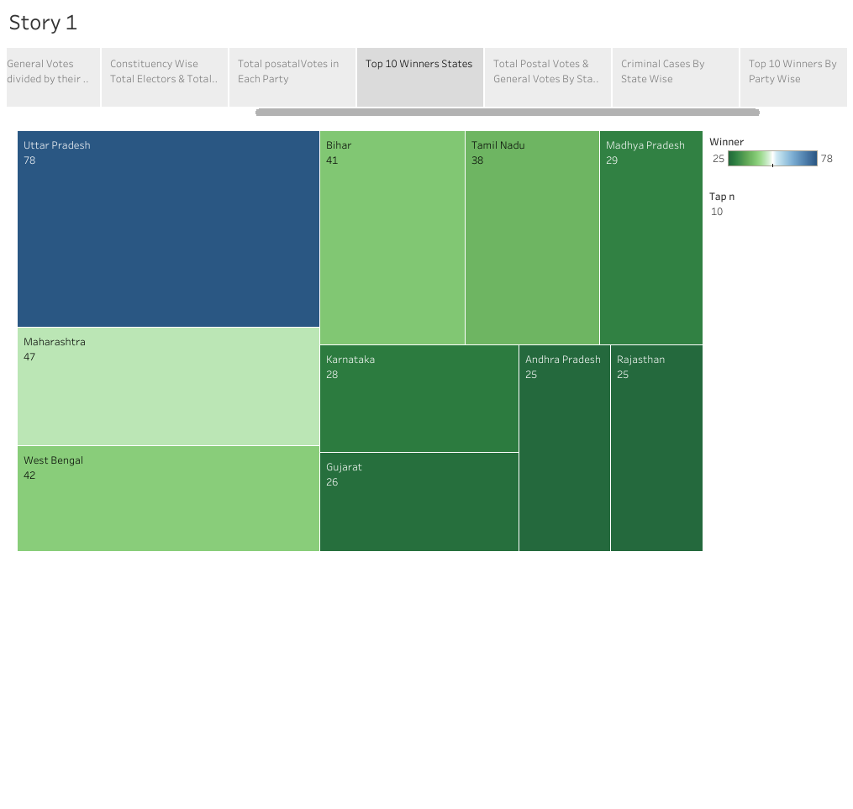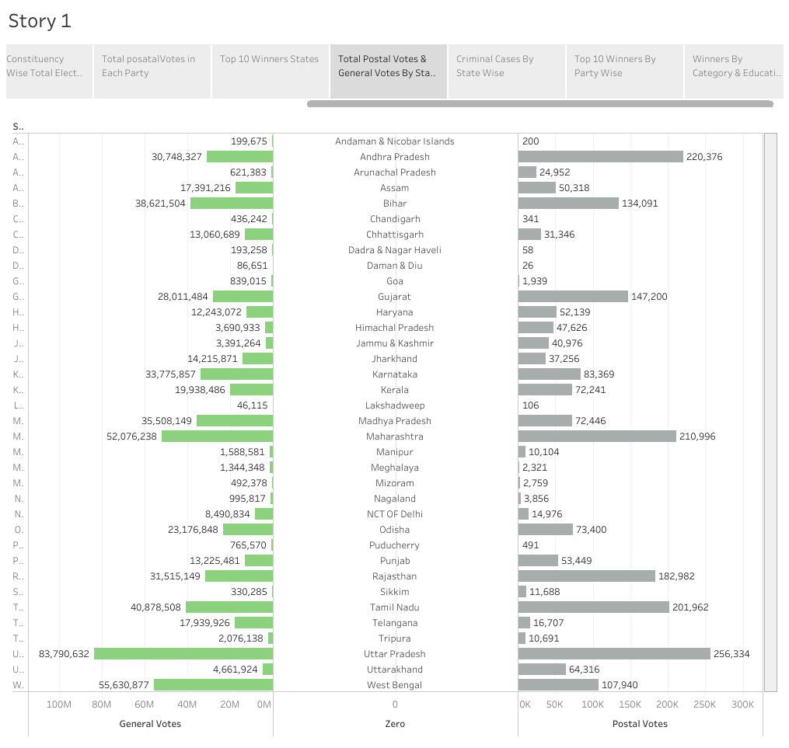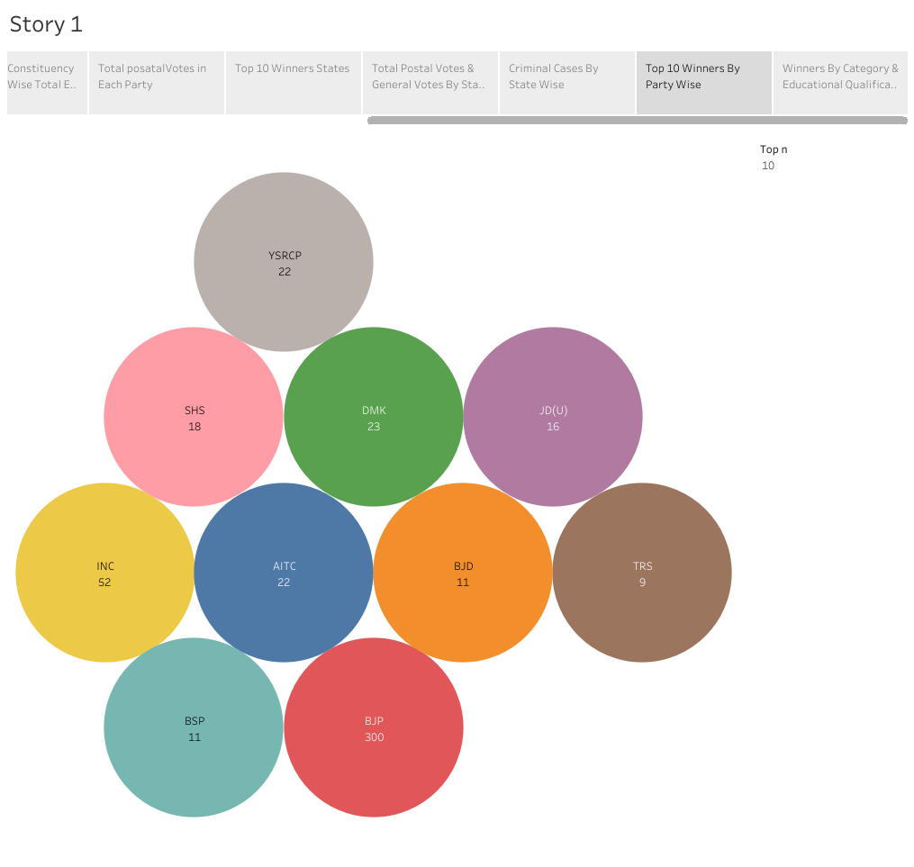

**ADVANTAGES:**

* **CAMPAIGN FUNDING:** Juggernauts tend to have access to substantial financial resources, allowingbthem to invest heavily in extensive advertising campaigns,rallies,and other voter outreach initiatives, which can be quantified through campaign expenditure analysis.
* **MEDIA COVERAGE: By measuring the extent of media coverage and its impact on voter perception, one can ascertain how political juggernauts benefit from consistent media attention,helping to shape public opinion and maintain a strong presence in the political discource.**
* **ELECTION RESULTS: A comprehensive aalysis of election results, including the percentage of votes received and the geographic distrution of support, can highlight the dominance of political juggernauts and their ability to secure victories across diverse regions, showcasing their widespread appeal and influence.**

**DISADVANTAGES:**

* **DIMINISHED COMPETITION: Their dominamce can stifle the entry of new candidates or political parties, reducing the electorate.**
* **LIMITED POLICY INNOVATION: Juggernauts often relyon traditional approaches, hindering the introduction of fresh, innovative policies that could benefit the public.**
* **POTENTIAL FOR CORRUPTION: With immense power, there’s a risk of increased corruption and a lock of accountability, leadind to the misuse of resources and unfair advantages in the political area.**

**APPLICATION:**

* **Analyzing the impact of political juggernauts in the 2019 election would involve studying their ability to influence voter behavior, fundraising capabilities, media presene, and their overall capacity to sway political discourse.**
* **A quantitative analysis of political juggernauts in the 2019 election could involve measuring various metrics, sush as campign expenditures, social media engagement, public opinion polling, fundraising amounts,and electroal results.**
* **By examining these data points, researchers can gain insights into the correction between the influence of political juggernauts and their respective electroal performance, helping to understand their impact on the election process.**

**CONCLUSION:**

* **While a comprehensive analysis would require an in-depth examination, the quantitative analysis of 2019 candidates in the election reveals the considerable influence of political juggernauts on campign financing, media attention, and overall electroal outcomes.**
* **In conclusion,our quantitative of candidates in the 2019 Lok Sabha elections provides valuable insights Into the dynamics of Indian democracy.**
* **By examining expenditure, voter turnout, and candidate performance, we gain a comprehensive understanding of the electroal process.**

**FUTURE SCOPE:**

* **The financial aspect of election campaigns is crucial. IN this slide, we analyze the campaigh expenditure of candidates. We explore the relationship between expenditure and electroal success, examining how candidates allocate their resources to maximize their chanches of victory.**
* **Keep in mind that political landscapes can change rapidily, so the future scope of political juggernauts is subject to various external factors, including public sentiment ,economic conditions, and global events.**
* **To conduct such an analysis, you would typically need access to a comprehensive dataset of candidate profiles, election results, demographics, and other relevant factors.**